Lab 7: Stack & Procedures
Learning Outcomes

- Students will be able to use real-time Stack using push and pop instructions.
- Students will be able to access Stack directly without using push and pop instructions.
- Students will be able to use Stack for various applications.
- Students will be able to define procedures, pass parameters to them, and return values from them.

The Stack

A stack is a Last-In-First-Out (LIFO) list that is attached to a program when it is loaded into memory for execution. This stack is managed by the hardware. The Stack Segment (SS) register points to the base of the stack, and the Stack Pointer (SP) register points to the top of the stack (TOS).

In 8086, a 16-bit register, or variable is pushed on the stack using PUSH instructions. The POP instruction, on the other hand, removes the values pointed to by SP in the same register.

If we push 1, 2, 3, 4, 5 one by one into the stack, the first value that we will get on pop will be 5, then 4, 3, 2, and then 1 as shown in the following figure.

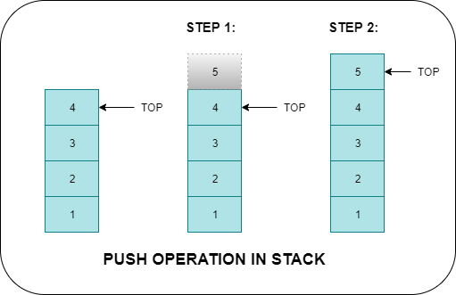

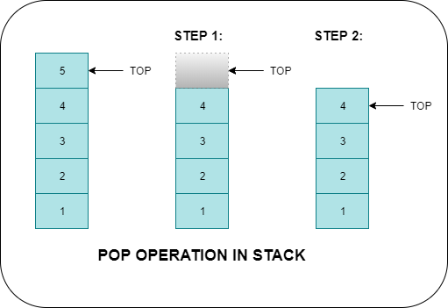

The instructions that push the operand to stack and pop it from stack are shown in the table below.

Instruction | Operation | Description
PUSH source | - SP ← SP – 2  - SS:[SP] ← source | Source:  - All general-purpose registers,  - All segment registers.  - Variables  - Immediate Value  - IP register cannot be pushed
POP destination | - Destination ← SS:[SP]  - SP ← SP + 2 | Destination:  - All general-purpose registers,  - All segment registers except CS & IP  - Word-type Variables

The following instructions push and pop flag registers into the stack.

Instruction | Operation | Description
PUSHF | - SP ← SP – 2  - SS:[SP] ← Flag register | - Stores flag registers on top of the stack
POPF | - Flag register ← SS:[SP]  - SP ← SP + 2 | - Mov value at top of the stack to flag register

Applications of Stack
Reusing registers simultaneously

There are a few registers in a processor to operate. Therefore, to use a register for another purpose, the contents of the register are temporarily pushed to the stack and popped later.

- Store the original value of the register in a stack (using PUSH).
- Use the register for any purpose.
- Restore the original value of the register from the stack (using POP).

Storing Return Address
When a function is called, the return address is pushed to the stack.

Declaring local variables
Global variables are declared and defined in data segments. However, local variables are stored on stack.

Accessing stack without using pop instructions

The Stack Segment can be accessed directly without using the POP instruction. We know that the stack segment is accessed when we use the BP register in register indirect addressing, i.e., [BP]. The contents of the SP register are moved to the BP register to gain access to the top of the stack. And then, using register indirect mode, the value at the top of the stack can be read or written.

Example:
Accessing top of the stack
Mov BP, SP MOV AX, [BP]

Example:
Accessing the second value from the top of the stack
Mov BP, SP MOV AX, [BP+2]

Example:
Accessing the third value from the top of the stack
Mov BP, SP MOV AX, [BP+4]

Procedures

A procedure is a part of code that can be called from your program to perform some specific tasks. Procedures make programs easier to understand. Generally, the procedure returns to the same point from where it was called.

The syntax for a procedure declaration is:
name PROC
; here goes the code
; of the procedure

RET
name ENDP

name- is the procedure name. The same name should appear at the top and bottom. This is used to ensure that procedures are properly closed.

RET- is required at the end of the procedure to return the program control back to where it came from.
The following table shows the instructions that are used to call a procedure and return control back.

Instruction | Operation | Description
Call label/ offset (2 bytes) | Push IP  IP ← Label | Calling procedure that is defined in the current code segment
Call label/ segment: offset (4 bytes) | Push CS Push IP  IP ← offset CS← segment | Calling procedure that is defined outside the current code segment
Ret | Pop IP | Returns control from procedure defined in the current code segment.
Retf | POP IP POP CS | Returns control from procedure defined outside the current code segment.

So far, we have not defined any procedure in a code segment. However, there should be a procedure inside the code segment, just as there is a main function in C/C++. From now on, we will write all the code in procedures. The main function is called by an operating system when we run a program.

Program#1:
Program that defines the main function in a program.
.model small

.stack

.data

.code Main proc

Mov ax,@data Mov ds,ax
.exit
Main endp

Parameter and Return value to/ from Procedures.

Procedures can be given data to processes, called parameters. These parameters can be passed via registers or through the stack. However, the procedures return values through the AL or AX register.

Program#2:
Program that defines the procedure “addition” to add two numbers, passed through registers, and return their sum.
.model small

.stack

.data

.code Main proc
Mov ax,@data Mov ds,ax
;Defining main procedure
Call addition
.exit
Main endp
;Calling procedure

;main procedure ends here
Addition proc Add ax,bx
;defining procedure
;adding two registers
Ret
Addition endp
;return control back to calling procedure

Program#3:
Program that defines the procedure “addition” to add two numbers, passed through stack, and return their sum.
.model small

.stack

.data

.code Main proc

Mov ax,@data Mov ds,ax
Mov ax,5 Mov bx,10 Push ax Push bx
;pushing value of ax, which is 5 to stack
;pushing value of bx, which is 10 to stack
Call addition
; calling procedure
Pop bx Pop bx
; removing number 10 from stack
; removing number 5 from stack
.exit
Main endp

Addition proc
;defining procedure
Push bp later
;storing value of BP on stack so that we can restore it
Mov bp,sp to bp
Mov ax,0
;to access stack without pop instruction—moving TOS

;no need to push AX as it is safe to use AX register
Add ax,[bp+4] Add ax,[bp+6]
; [bp+4] contains value 10
; [bp+6] contains value 5
Pop bp
; restoring value of BP from stack
Ret
Addition endp
; transferring control back to the calling procedure

Program that defines the procedure “addition” to sum up an array of 5 elements and return its sum. Note: Array is always passed by reference.
.model small
.data
array db 1,2,3,4,5
.code Main proc
Mov ax,@data Mov ds,ax

Mov bx,offset array ;base address of array mov ax,5 ;size of array

Push bx Push ax
Call addition
;calling procedure
pop bx pop bx
;removing parameters from stack
;removing parameters from stack
.exit
Main endp

Addition proc ;Defining procedure
push bp push cx push si
;saving the value of BP on stack before using it
;saving the value of CX on stack before using it
;saving the value of SI on stack before using it
mov bp,sp ;moving top of the stack to bp mov cx,[bp+8] ;reading size of array
mov ax,[bp+10] ;reading base address of array mov bp,ax ;moving base address to BP
mov ax,0 ; it is safe to use ax without pushing it mov si,0 ;assigning index register with 0
l1:
Add al,ds:[bp+si] ;accessing value 10
inc si loop l1 pop si pop cx pop bp
;incrementing index by 1 as the array is of a byte type
;Restoring original value of SI from stack
;Restoring original value of CX from stack
;Restoring original value of BP from stack
ret ;returning control back to calling procedure Addition endp

Program#5:
Program that creates local variables.
.model small

.data

.code Main proc
push bp
; storing value of bp on stack
; now you may PUSH and POP equal number of times here
Main endp

mov sub | bp,sp sp,4 | ;creating space on stack for two variables
mov | word ptr [bp-2],5 | ; assigning value to local variable
mov | word ptr [bp-2],10 | ; assigning value to local variable

mov | sp,bp | ;destroying local variables before returning
pop | bp | ; restoring value of bp from stack
ret

.exit

Emu8086 Tutorial Step by Step

Step-1:
Double click on the icon on the desktop 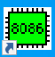

The following window will appear. Click on “new”.
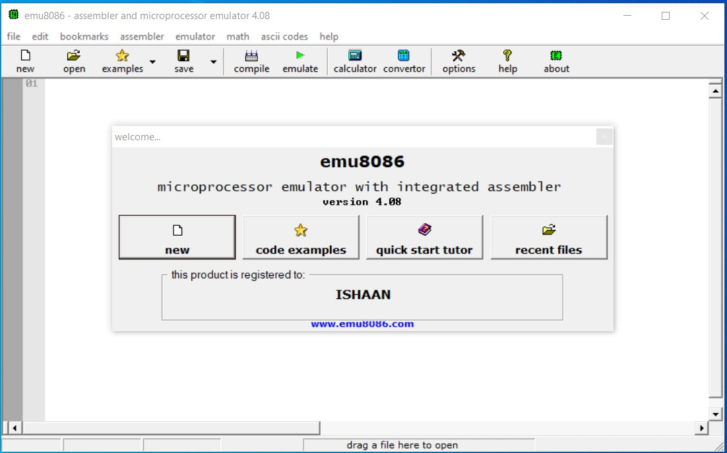
Step-3:
Click on the “empty workspace” and press “OK”.
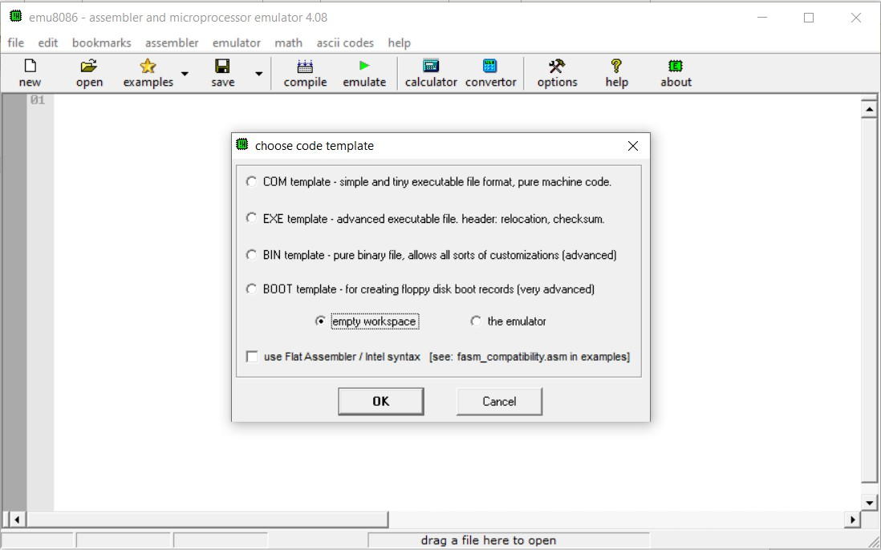

Type the code given in program#3 above and click on “emulate”.
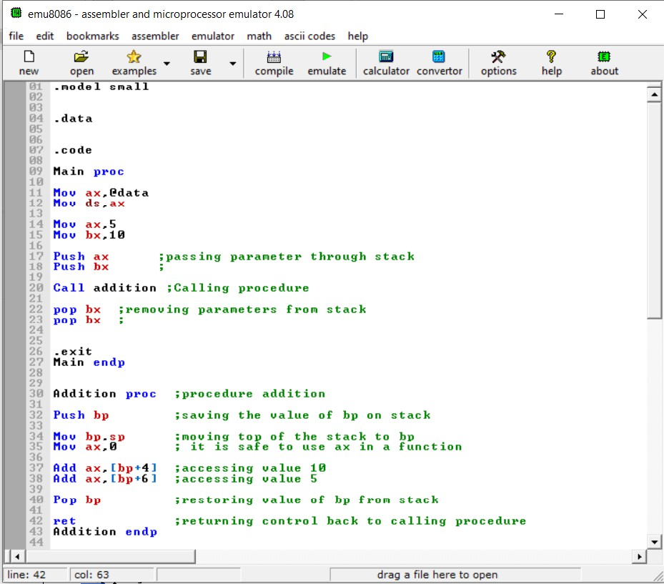

Step-5:
Click on the Stack to view stack window.
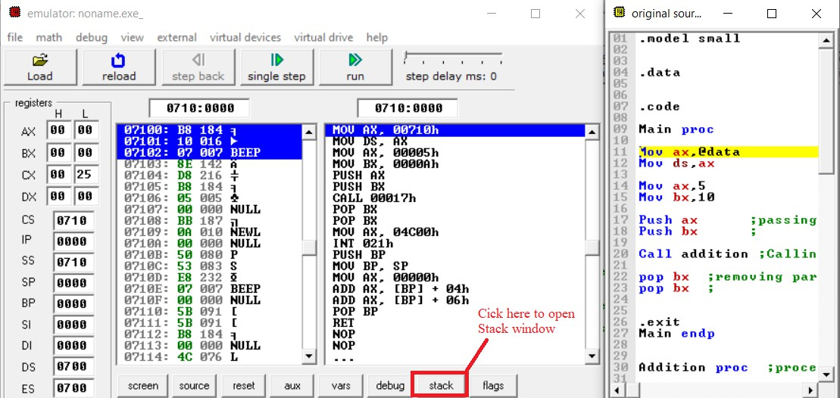
Step-6:

Keep clicking on "Single Step" to execute program instructions one by one and observe the top of the Stack side by side.

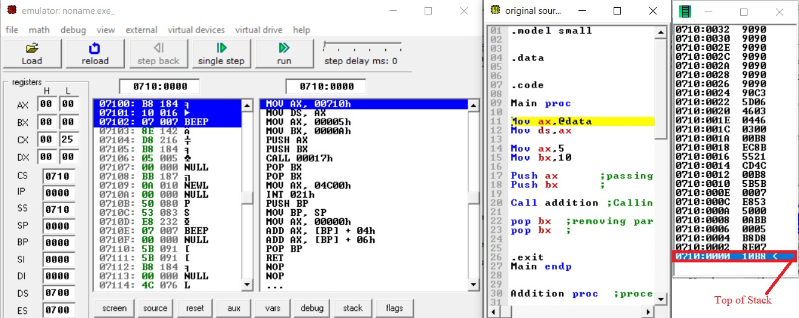

Observations

Which address is pushed to stack when a procedure is called? At what address is control transferred when a procedure returns?
How have [BP+4] and [BP+6] been calculated for the desired locations of parameters?

Lab-7 Exercise

Task-1
Write a program that defines the procedure "SUM." The procedure receives three arrays: A, B, and C, and the sizes of the arrays through a parameter. The procedure adds corresponding elements from arrays A and B and stores the sum in array C.

Task-2
Write a program that declares a byte array and stores an English word into it. The program then checks if the array contains a palindrome. It stores 1 in the DL register in the case of palindromes and 0 otherwise

